***Name:Bijapure Naheen***

***R.No:08***

***ISE-2***

***Q1.***

***Code:***

*<!DOCTYPE html>*

*<html>*

*<div style="text-align: center;">*

*<img id="img" src="ONbulb.jpg" style="height: 300px;" alt="Bulb img"><br>*

*<button id="button" onclick="fu()">Turn OFF</button>*

*<h1 id="bulbstatus">Bulb On-Off</h1>*

*</div>*

*<script>*

*var c = 0;*

*function fu(){*

*if(c==0){*

*document.getElementById('img').src = "OFFbulb.jpg";*

*document.getElementById("button").innerHTML = "Turn ON";*

*c=1;*

*document.getElementById("bulbstatus").innerHTML = "Bulb in OFF Now!";*

*}*

*else if(c==1){*

*document.getElementById("img").src = "ONbulb.jpg";*

*document.getElementById("button").innerHTML = "Turn OFF";*

*c=0;*

*document.getElementById("bulbstatus").innerHTML = "Bulb in On Now!";*

*}*

*}*

*</script>*

*</body>*

*</html>*

***Output:***

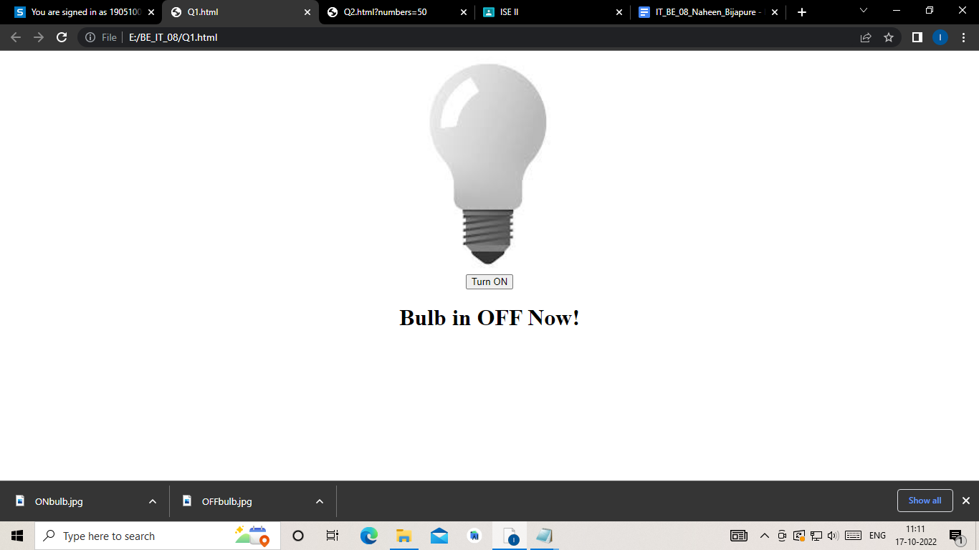

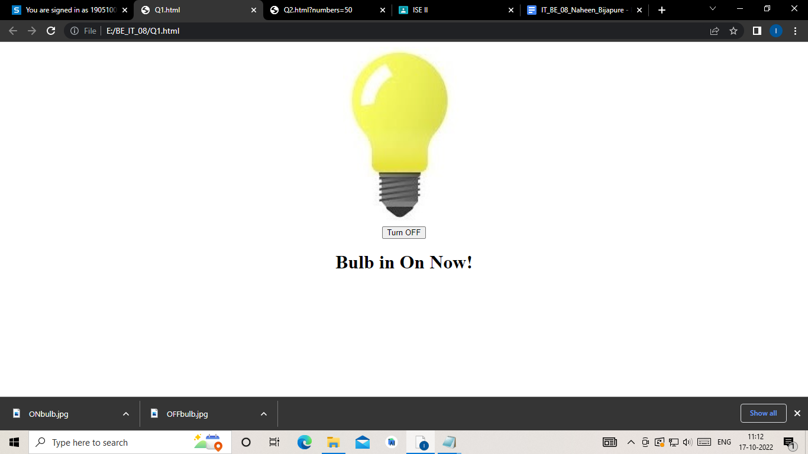

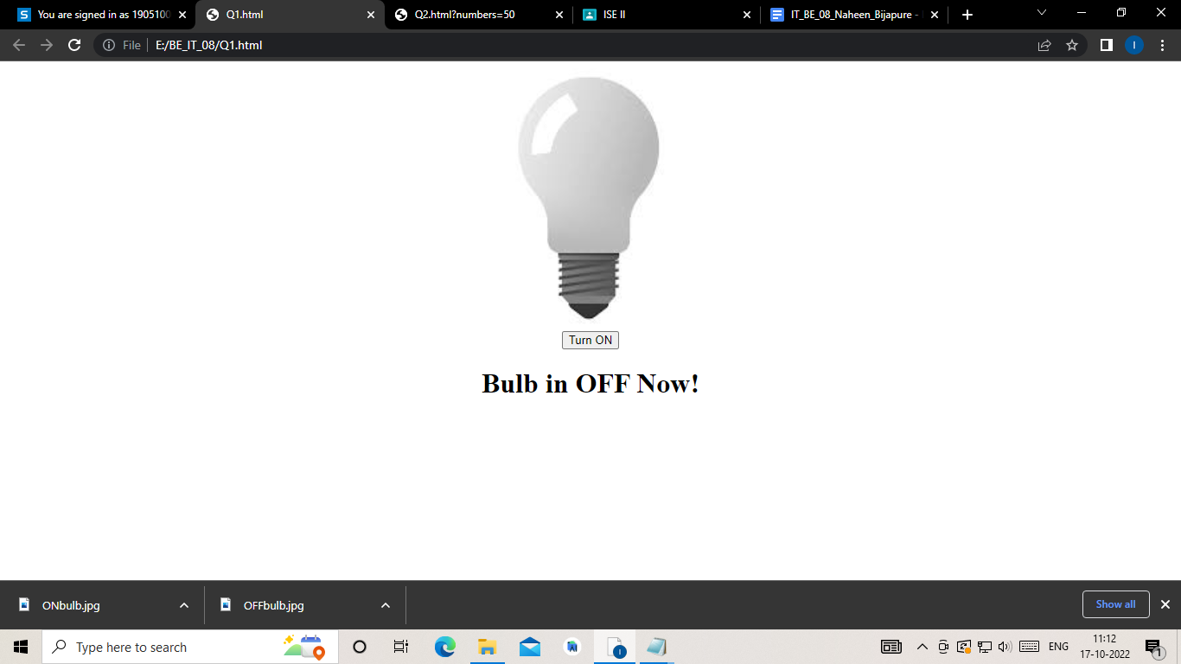

***Q2.***

***Code:***

*<!DOCTYPE html>*

*<html>*

*<body>*

*<h2>Number Validation</h2>*

*<p>Please input a number between 1 and 100:</p>*

*<input id="numb">*

*<button type="button" onclick="myFunction()">Submit</button>*

*<p id="demo"></p>*

*<script>*

*function myFunction() {*

*// Get the value of the input field with id="numb"*

*let x = document.getElementById("numb").value;*

*// If x is Not a Number or less than one or greater than 10*

*let text;*

*if (isNaN(x) || x < 1 || x > 100) {*

*text = "Input not valid";*

*} else {*

*text = "Input OK";*

*}*

*document.getElementById("demo").innerHTML = text;*

*}*

*</script>*

*</body>*

*</html>*

***Output:***

